Vital Health Index (VHI) – Project Report

Subject: CPE-213 Microcontroller

Group: R2 Chan Ui Sang Le B

# Table of Contents

1. 1. Introduction
2. 2. Features
3. 3. System Components
4. 4. Pin Configuration
5. 5. How to Use the Device
6. 6. System Workflow
7. 7. Block Diagram
8. 8. Circuit Diagram
9. 9. 3D Model of Device
10. 10. Actual Device Images
11. 11. Demo
12. 12. Conclusion

# 1. Introduction

This project aims to create a portable health monitoring device capable of measuring:  
- Heart Rate (HR)  
- Blood Oxygen Saturation (SpO₂)  
- Body Mass Index (BMI)  
  
The system is built using the ESP32 DOIT DEVKIT V1 microcontroller, with the MAX30100 Pulse Oximeter for HR and SpO₂ measurement, and a KY-040 rotary encoder for user input. The output is displayed on a 128×64 Adafruit SSD1306 OLED, with additional feedback provided through LEDs and a buzzer.  
  
By combining HR, SpO₂, and BMI monitoring, the device can be used in hospitals, clinics, and personal health applications.

# 2. Features

* Measure Heart Rate.
* Measure Blood Oxygen Level (SpO₂).
* Calculate Body Mass Index (BMI).
* Display results clearly on OLED screen.
* Interactive rotary encoder input with push button.
* Real-time LED & buzzer feedback on heartbeats.

# 3. System Components

Inputs:

* ESP32 DOIT DEVKIT V1
* Expansion board for ESP32
* MAX30100 Pulse Oximeter & HR sensor
* KY040 Rotary Encoder with push button

Outputs:

* SSD1306 OLED 128×64 display
* Buzzer
* LEDs (heartbeat indicators)

# 4. Pin Configuration

|  |  |
| --- | --- |
| Component | Pin |
| Encoder Switch (SW) | 4 |
| Encoder DT | 2 |
| Encoder CLK | 15 |
| LED 1 | 12 |
| LED 2 | 13 |
| Buzzer | 14 |
| OLED (I²C) | SDA/SCL (default) |

# 5. How to Use the Device

1. Power On – Connect the device to a power source.  
2. Navigate Menu – Use the rotary encoder:  
 - Rotate → switch between Heart Rate and BMI Calculator modes.  
 - Press → confirm selection.

Heart Rate Mode:

1. Place your finger on the MAX30100 sensor.  
2. Wait for ~10 seconds while the system collects 10 readings.  
3. LEDs and buzzer will respond to detected heartbeats.  
4. OLED shows average HR (bpm) and SpO₂ (%).  
5. Press button → return to menu.

BMI Calculator Mode:

1. Rotate encoder → set weight. Press to confirm.  
2. Rotate encoder → set height. Press to confirm.  
3. OLED shows BMI value and category (Underweight, Normal, Overweight, Obese).  
4. Press button → return to menu.

3. Power Off – Disconnect power when done.

# 6. System Workflow

1. Start → Initialize pins, OLED, MAX30100, Encoder, Button.  
2. Main Menu → User selects mode.  
3. Heart Rate Mode → Measures HR & SpO₂, averages results, displays.  
4. BMI Mode → User inputs height & weight, calculates BMI, displays.  
5. Return to Menu → Loops back to allow new selection.

# 7. Block Diagram

# 8. Circuit Diagram

Insert schematic diagram here.

# 9. 3D Model of Device

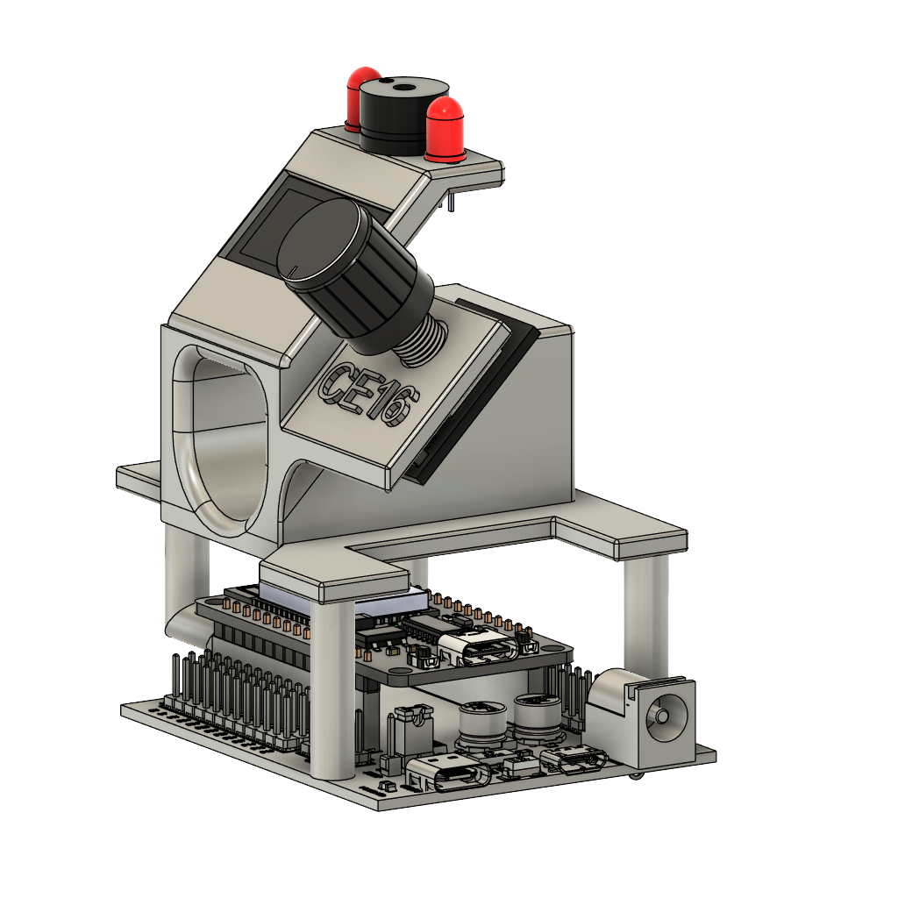

# 10. Actual Device Images

# 

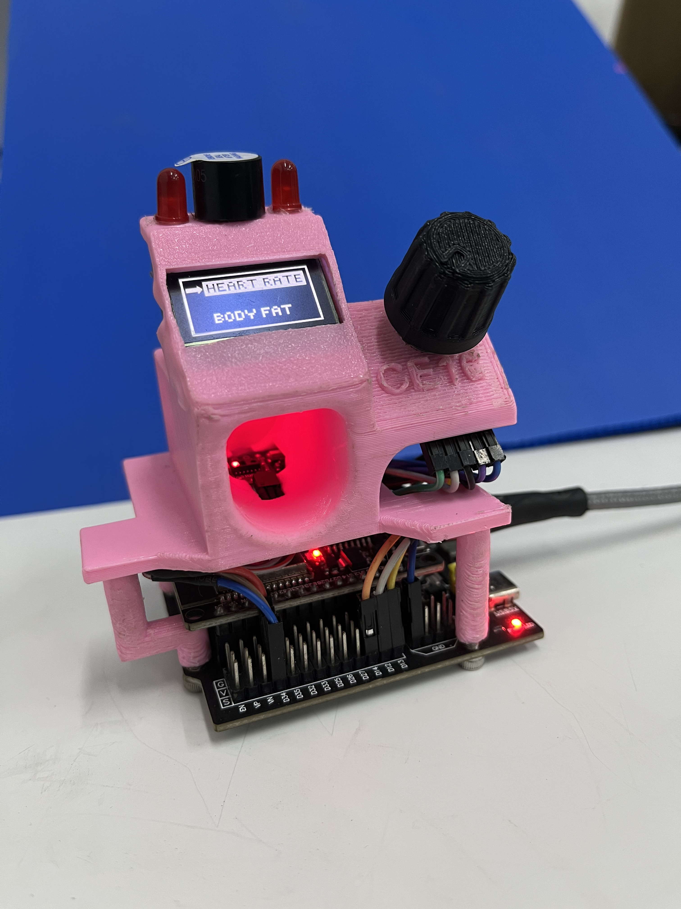

# 11. Demo

Demo Video Link: https://github.com/user-attachments/assets/d4290b7f-eb62-4639-8b0b-7ba6046d94cb

# 12. Conclusion

The Vital Health Index (VHI) successfully integrates heart rate monitoring, blood oxygen measurement, and BMI calculation into a single, user-friendly device. By using the ESP32 microcontroller with efficient sensors and intuitive controls, the system demonstrates how microcontrollers can be applied in health monitoring applications.  
  
This project enhances user accessibility, provides accurate health data, and can be further developed into wearable or IoT-integrated healthcare devices.